ENGLISH

**Mark Franklind Braithwaite**

Sweden

Asia-Pacific (APAC) President of Höganäs AB

1. Degree in Chemistry 1991-1994 and qualified as Chartered Accountant (ACA) in 1998;

2. Started career as auditor with PwC then Merrill Lynch Investment Banking;

3. Joined Swedish engineering company Höganäs AB in 2003 in UK and held various positions most recently as group CFO until 2018 when I moved to China as President of APAC.

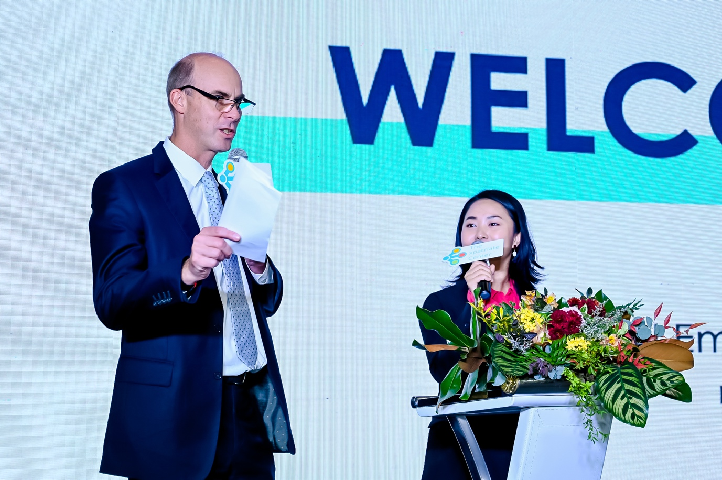

Supported TEC at various events including discussion panel and as an Emcee.

中文

**Mark Franklind Braithwaite**

瑞典

Höganäs AB 亚太区总裁

1. Degree in Chemistry 1991-1994 and qualified as Chartered Accountant (ACA) in 1998;

2. Started career as auditor with PwC then Merrill Lynch Investment Banking;

3. Joined Swedish engineering company Höganäs AB in 2003 in UK and held various positions most recently as group CFO until 2018 when I moved to China as President of APAC.

1. 1991-1994年获得化学学士学位，1998年获得英国特许会计师资格;

2. 最初在普华永道担任审计师，后来在美林投资银行担任审计师;

3. 2003年在英国加入瑞典工程公司Höganäs AB，担任过各种职位，最近担任集团首席财务官，直到2018年搬到中国担任亚太区总裁。

积极支持TEC的各种活动，包括参与座谈会和当主持人。